**SE4050 – DL**

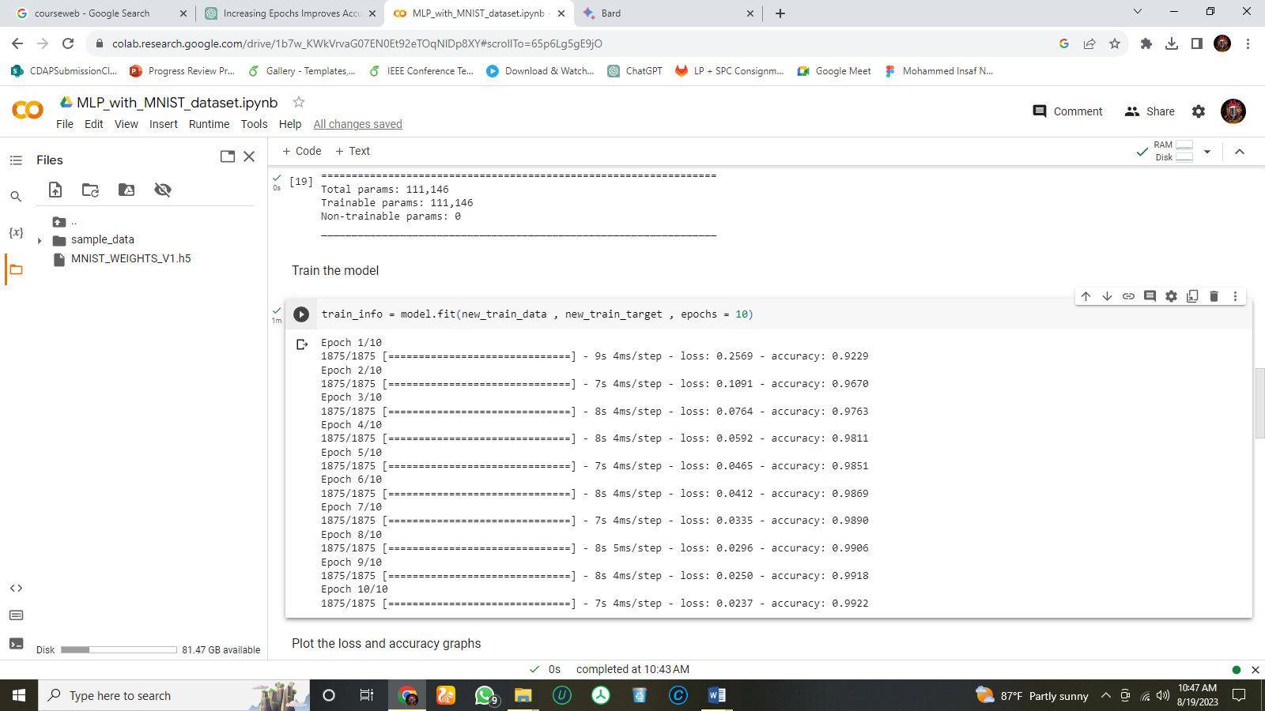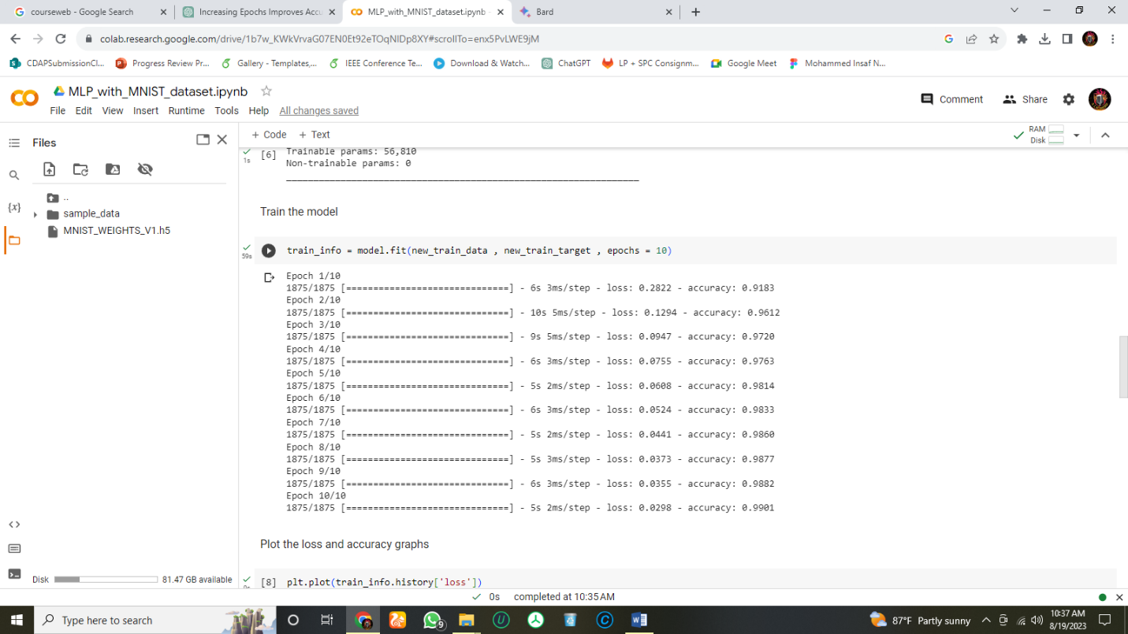**Lab 02**

Figure 2: Results after changing Hidden Units

Figure 1: Initial Results

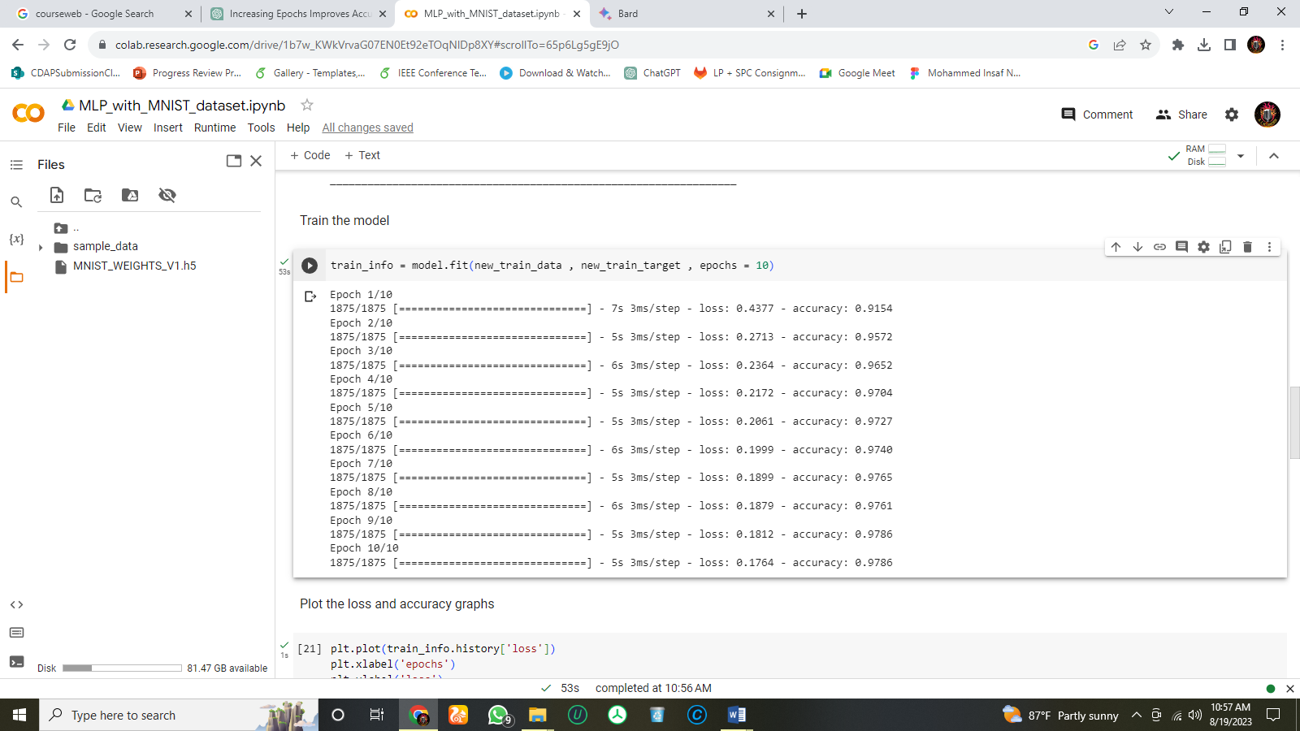

Figure 4: Results after introducing Regularization

Figure 3: Results after changing Epochs (10->20)

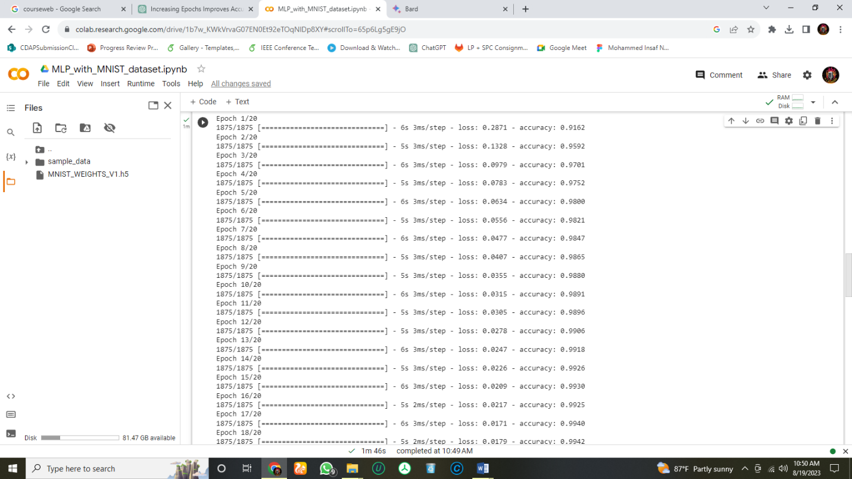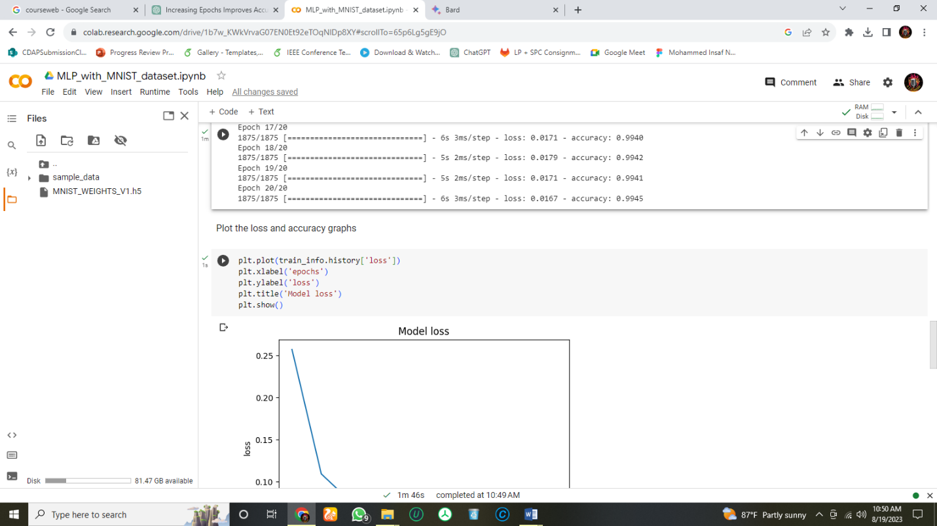



Figure 5: Confusion Matrix

1.

Increasing the number of hidden units in a neural network can improve its accuracy by allowing it to capture more complex patterns in the data. However, too many hidden units can lead to overfitting, which occurs when the model learns the training data too well and is not able to generalize to new data. Similarly, increasing the number of epochs can also improve the accuracy of a neural network. This is because the model has more opportunities to learn from the training data. However, too many epochs can also lead to overfitting. Therefore, it is important to stop training the model when the accuracy on the validation data starts to plateau. Finding the right balance between the number of hidden units, the number of epochs, and other hyper parameters is essential to achieve the best performance on unseen data. This can be done through a process called hyper parameter tuning, which involves experimenting with different values of the hyper parameters and evaluating the performance of the model on the validation data.

2.

Introducing regularization to a neural network can have both positive and negative impacts. Regularization prevents overfitting by adding a penalty to weights, promoting a balanced model. The regularization's strength is controlled by a hyper parameter. Small values may lead to overfitting, while large ones can cause under fitting. Thus, careful selection is key. Experiment with different values, assess on validation data, and adjust. If over-regularized, accuracy might suffer, indicating under fitting. In this scenario, its impact reveals subpar performance and fails to enhance the overall accuracy.